MercadoPago – Magento 1.5.x & 1.6.x

Installation instructions

Compatible with Magento 1.4,1.5,1.6

- Copy the folds "APP" and "Skin" to the Magento root installation. Make sure to keep the Magento folders structure intact.
- In your admin go to System>Cache Management and clear all caches.
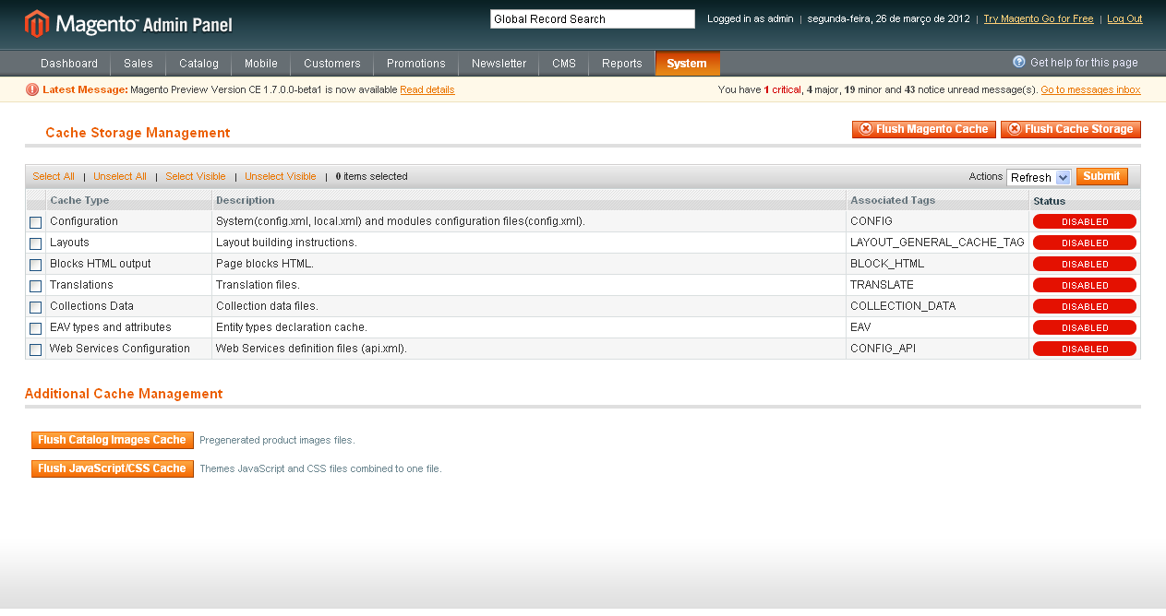
- Go to System>IndexManagement and select all fields. Then click in Reindex Data.
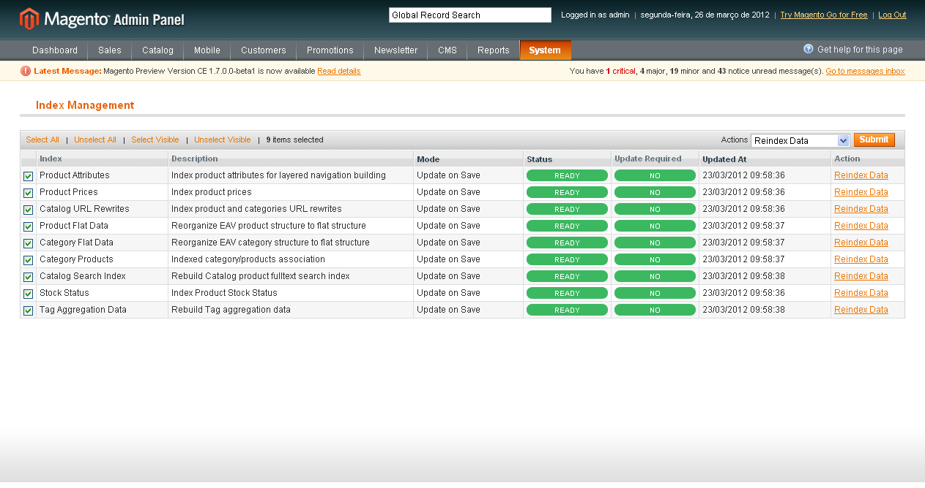

Set up MercadoPago Magento plugin

- Go to System>Configuration>Sales/Payment Methods. Select MercadoPago.
- Set your Country where your account was created and save config.
- Set your Client_id and Client_Secret. You could get in:
  - Argentina: https://www.mercadopago.com/mla/herramientas/aplicaciones
  - Brazil: https://www.mercadopago.com/mlb/ferramentas/aplicacoes
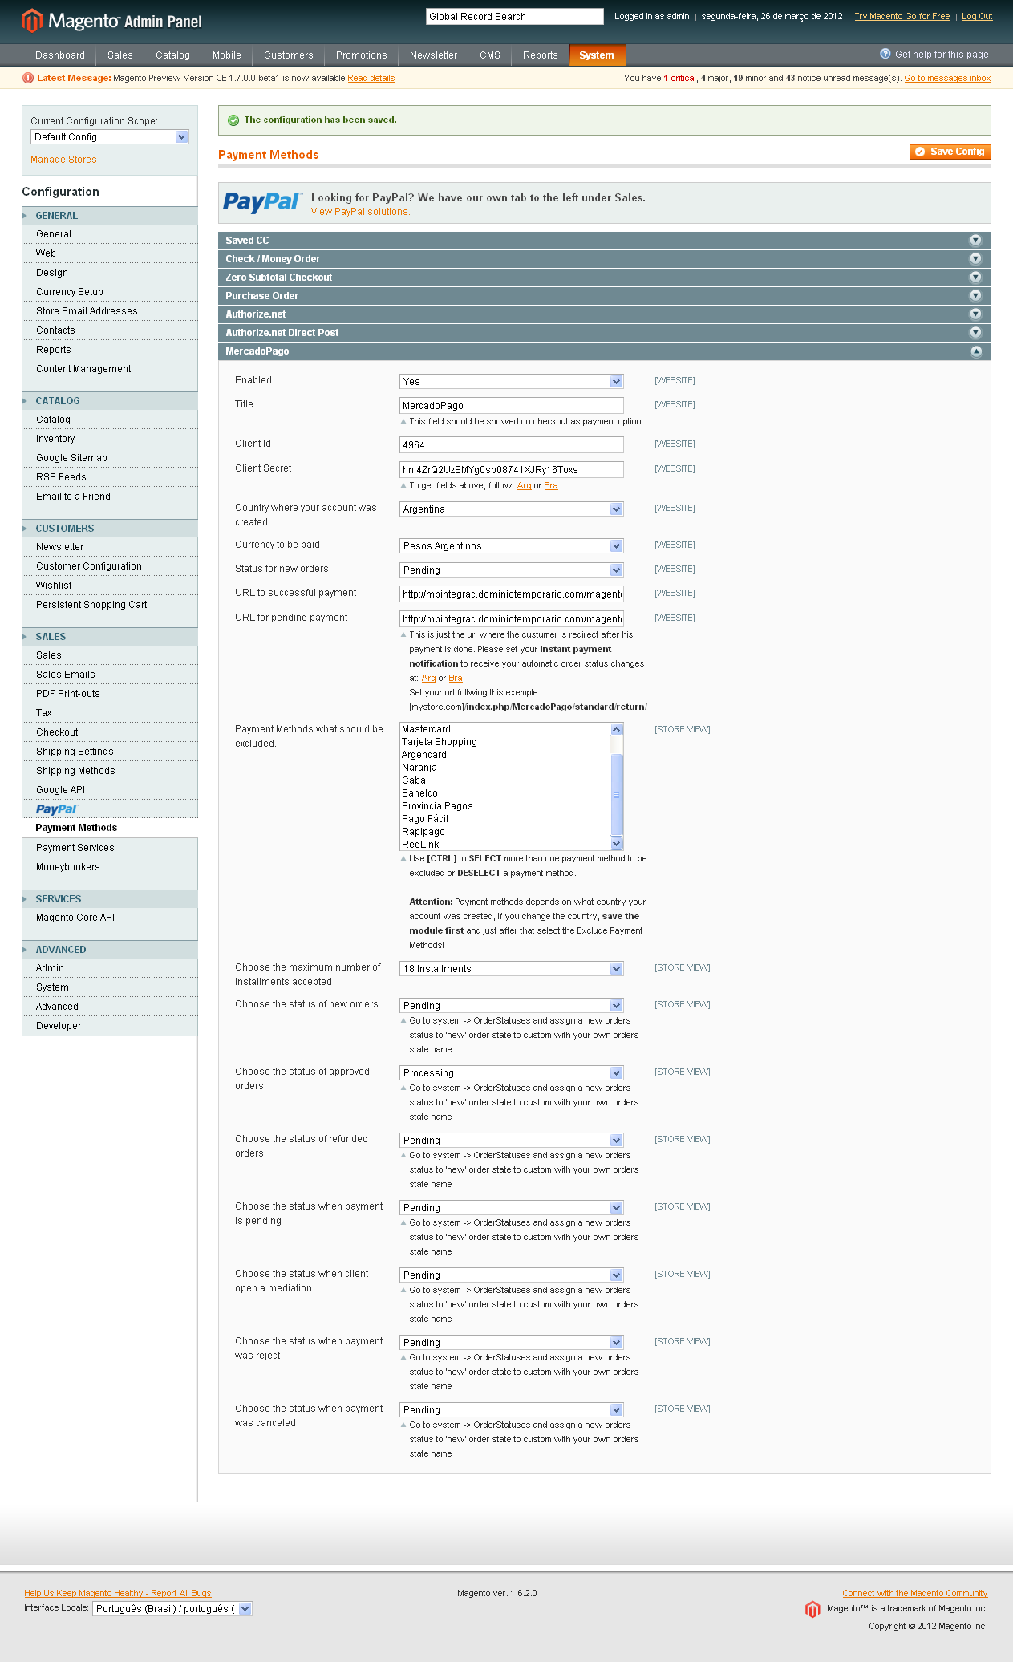
- Note: If you change the Country where your account was created you need save config to refresh the excluded payment methods.
- Note: The standard URL for successful payment or pending payment is [yourstoreaddrees.com]/index.php/checkout/onepage/success/ but you can use any page as you want.

Sync your backoffice with MercadoPago (IPN)

- Go to MercadoPago IPN admin page:
  - Argentina: https://www.mercadopago.com/mla/herramientas/notificaciones
  - Brazil: https://www.mercadopago.com/mlb/ferramentas/notificacoes
- Enter the URL as follow [yourstoreaddrees.com]/index.php/MercadoPago/standard/return/

